**Following are the results of uncontrolled simulation of satellite for different cases.**

* po stands for satellite in circular orbit passing through the poles.
* sso stands for sun synchronous orbit in which we have given TLE of Pratham as an input.
* Identity means moment of Inertia of satellite is identity matrix.
* Advitiy means moment of Inertia of satellite is of Advitiy (as obtained from SolidWorks model)
* dist means simulation is done with disturbance torque.
* no-dist means simulation is done without disturbance torque.

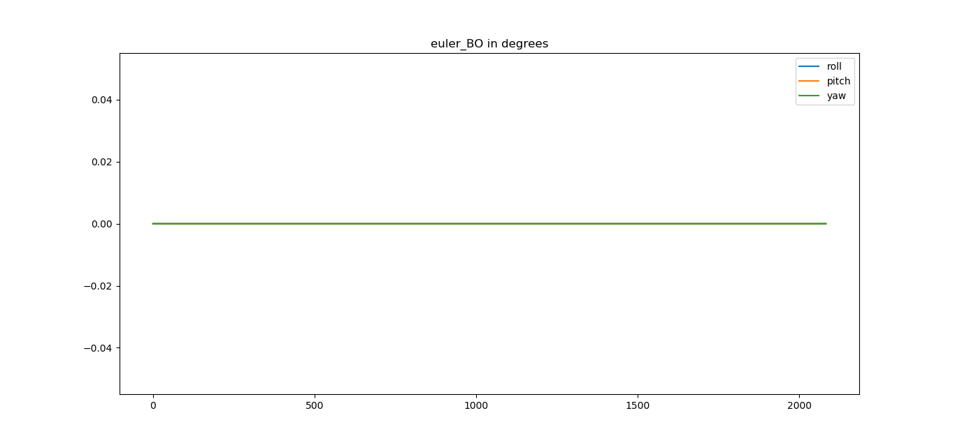

Figure 1: po-identity-no-dist-eulerangles

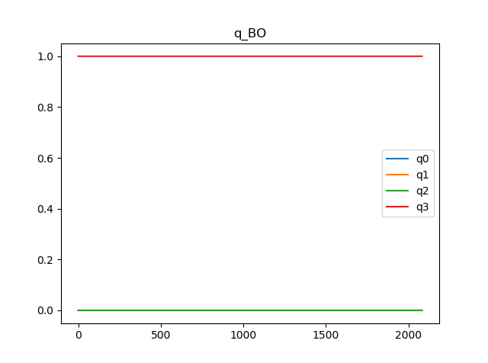

Figure 2: po-identity-no-dist-quaternion

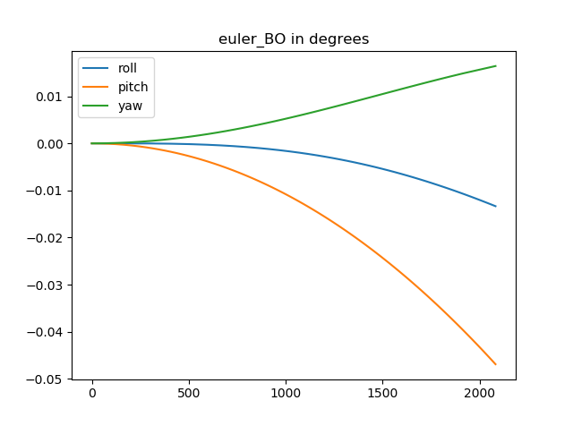

Figure 3: po-identity-dist-eulerangles

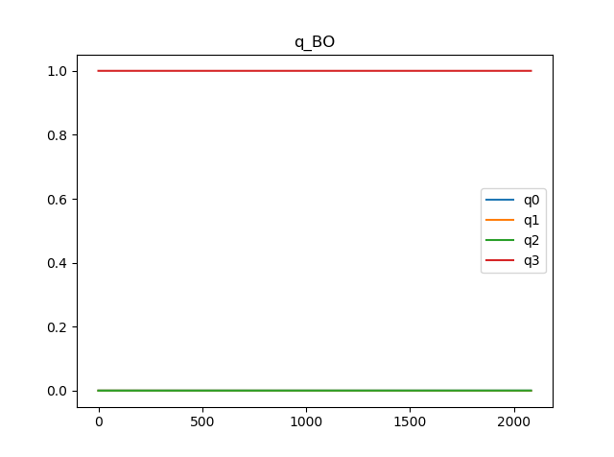

Figure 4: po-identity-dist-quaternion

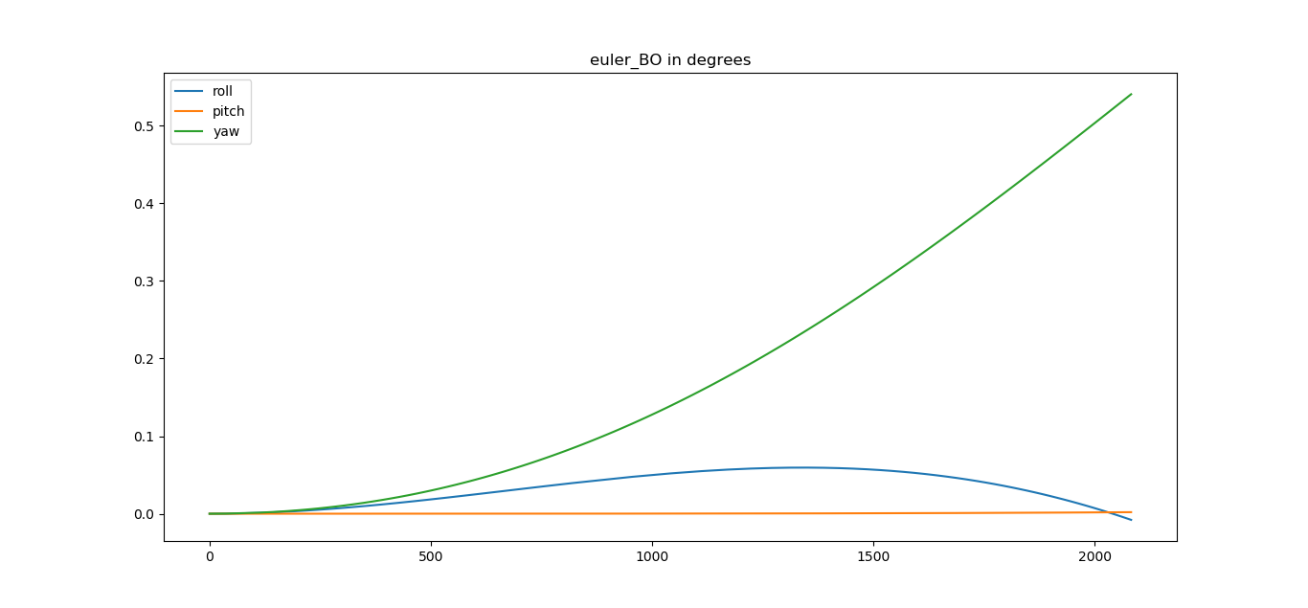

Figure 5: po-advitiy-no-dist-eulerangles

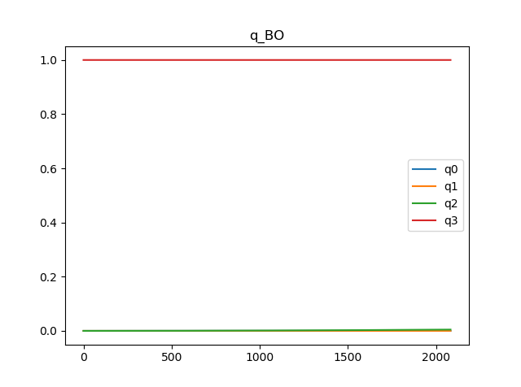

Figure 6: po-advitiy-no-dist-quaternion

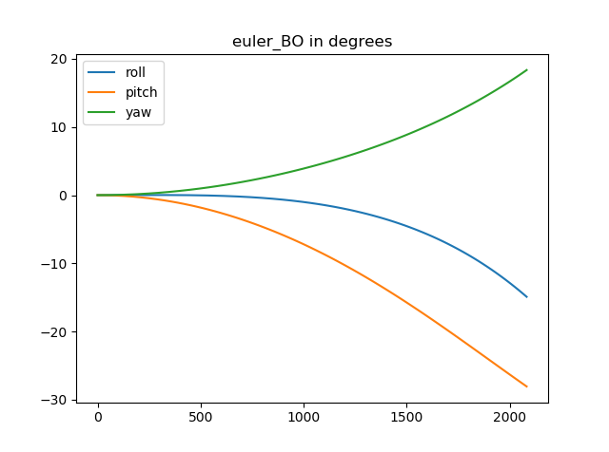

Figure 7: po-advitiy-dist-eulerangles

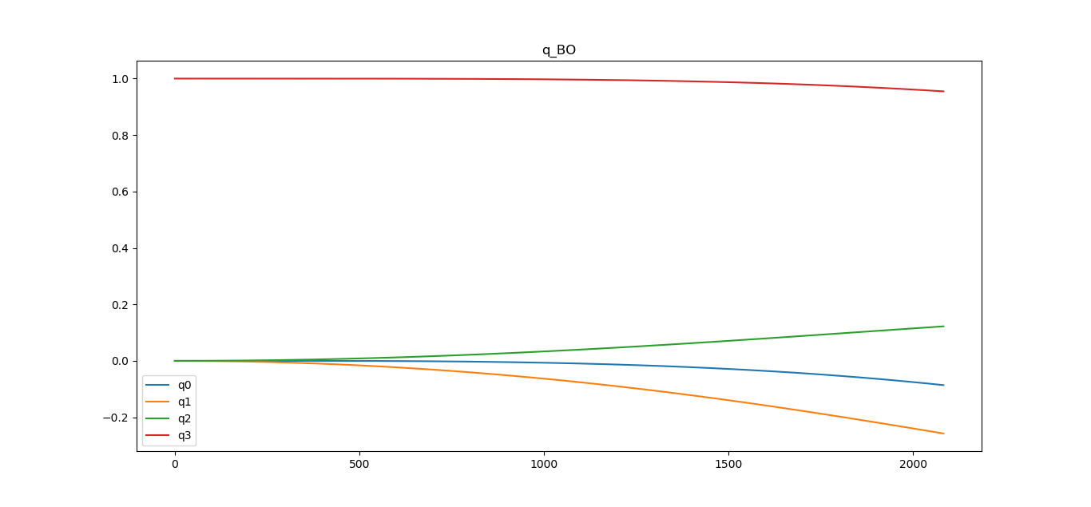

Figure 8: po-advitiy-dist-quaternion

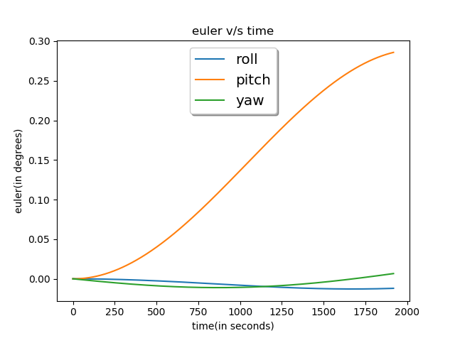

Figure 9: sso-identity-no-dist-eulerangles

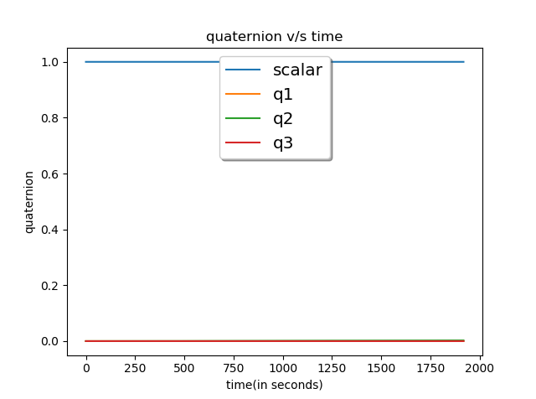

Figure 10: sso-identity-no-dist-quaternion

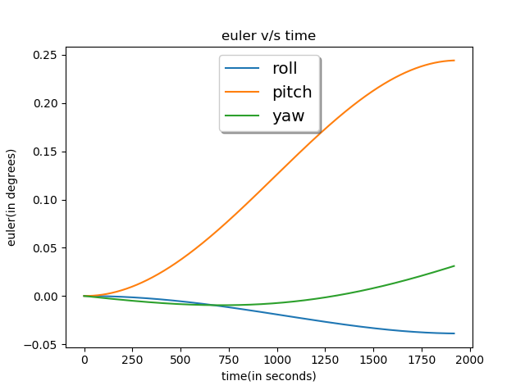

Figure 11: sso-identity-dist-eulerangles

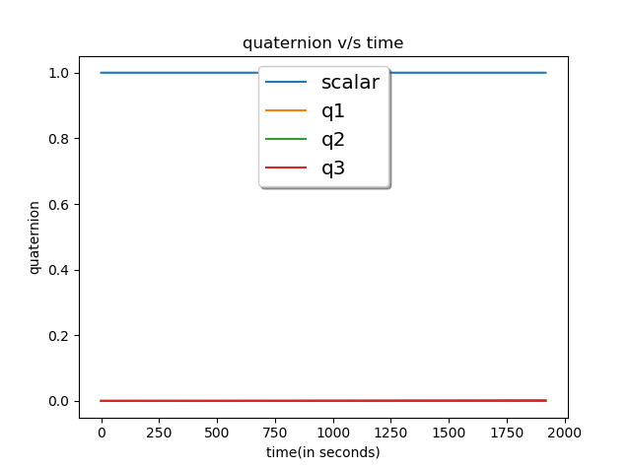

Figure 12: sso-identity-dist-quaternion

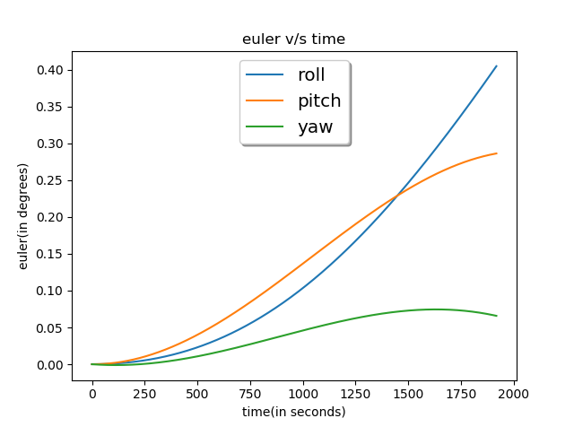

Figure 13: sso-advitiy-no-dist-eulerangles

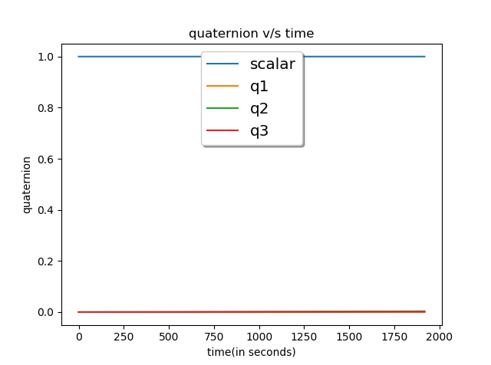

Figure 14: sso-advitiy-no-dist-quaternion

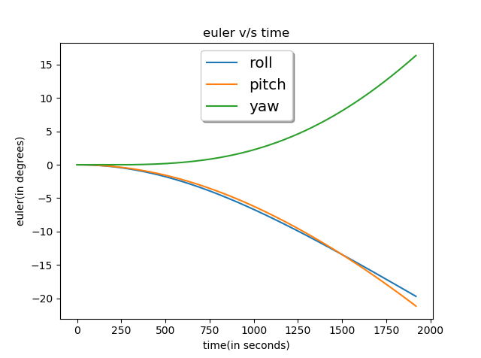

Figure 15: sso-advitiy-dist-eulerangles

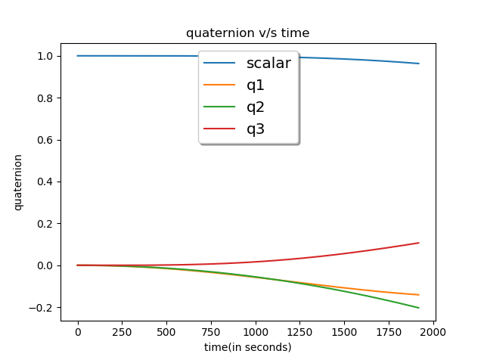

Figure 16: sso-advitiy-dist-quaternion